**Contents Table for Chapter Food Services**

|  |  |
| --- | --- |
| **Ex 1. What Can You Find In A Professional Kitchen?..................................................** | **82** |
| **Ex 2. Working With Recipes..........................................................................................** | **83** |
| 2A. Video recipes............................................................................................................................... | 83 |
| 2B. Filling in information ................................................................................................................. | 83 |
| 2C. Writing out a recipe.................................................................................................................... | 84 |
| 2D. Making your own recipe............................................................................................................ | 85 |
| **Ex 3. Cooking Techniques............................................................................................** | **88** |
| 3A. Thought shower/pooling.......................................................................................................... | 88 |
| 3B. Definitions.................................................................................................................................... | 88 |
| 3C. Definitions and images .............................................................................................................. | 89 |
| **Ex 4. Games...................................................................................................................** | **91** |
| 4A. Matching terms and functions 1............................................................................................... | 91 |
| 4B. Matching terms and functions 2............................................................................................... | 91 |
| 4C. Memory game.............................................................................................................................. | 91 |
| **Ex 5. Do’s And Don’ts....................................................................................................** | **92** |
| 5A. Thought shower/pool................................................................................................................ | 92 |
| 5B. Rules 1........................................................................................................................................... | 92 |
| 5C. Rules 2........................................................................................................................................... | 93 |
| 5D. Rules 3.......................................................................................................................................... | 94 |

|  |  |
| --- | --- |
| **Ex 6. Formal Speech................................................................................................** | **96** |
| 6A. Formal and informal register............................................................................................ | 96 |
| **Ex 7. An Informal Dialogue....................................................................................** | **98** |
| 7A. A listening exercise............................................................................................................. | 98 |
| 7B. Ordering text....................................................................................................................... | 98 |
| 7C. Informal dialogue: phrase gap fill..................................................................................... | 98 |
| 7D. Role play: an informal dialogue........................................................................................ | 98 |
| **Ex 8. Formal Dialogue............................................................................................** | **99** |
| 8A. Listening exercise ............................................................................................................... | 99 |
| 8B. Ordering text....................................................................................................................... | 99 |
| 8C. Formal dialogue: phrase gap fill........................................................................................ | 99 |
| 8D. Role play: a formal dialogue.............................................................................................. | 99 |
| 8E. Discussing attitudes............................................................................................................ | 99 |
| **Ex 9. Challenging Situations – Creating Dialogues................................................** | **100** |
| **Ex 10. Taboo............................................................................................................** | **101** |
| **Ex 11. A Perfect Cappuccino...................................................................................** | **102** |
| 11A. How to make a perfect cappuccino............................................................................... | 102 |
| 11B. Writing the six steps to making a cappuccino.............................................................. | 102 |
| 11C. Ordering sentences........................................................................................................... | 103 |
| 11D. Explaining the six steps................................................................................................... | 103 |
| **Ex 12. Drink Categories...........................................................................................** | **104** |
| **Ex 13. Cocktails: Ingredients And How To Make A Cocktail................................** | **107** |
| 13A. How to make a Mojita..................................................................................................... | 107 |
| 13B. Create a cocktail................................................................................................................ | 107 |
| 13C. A good bartender.............................................................................................................. | 109 |

**UK Food Services Sector Fact Sheet**

**CFSP (Certified Food Service Professional)** is the industry specific professional qualification for the UK Food Service industry. It is being introduced under the auspices of CESA (Catering Equipment Suppliers Association), which is already an established & highly regarded body within the industry. CESA’s objective is to help improve the levels of professionalism in the sector by creating a universally recognised and respected industry ‘standard’ for knowledge and experience.

[http://www.cfsp.org.uk](http://www.cfsp.org.uk/)

According to The National Careers Service, “the sector accounts for a workforce of 2.1 million, most of which are based within the restaurants, hospitality services, and pubs, bars and nightclubs industries. The roles within the sector are extremely diverse and include managers, technical staff, front-of-house staff, back-of-house staff, and non-core staff.

“The restaurant industry includes: fast food establishments – such as McDonalds, Burger King and KFC, as well as traditional outlets such as fish and chips shops, sushi bars and sandwich bars; cafes and coffee shops; mainstream restaurants – these are high street restaurants which tend to be mid‐price and include many branded and themed chains such as Pizza Express, Garfunkel’s and Ask; fine dining – these tend to be more expensive restaurants that offer unique dishes and, sometimes, more experimental cuisine.

“Jobs in the industry range from: kitchen assistants, bar manager, general manager, chef, cleaner,

conference and banqueting manager, waiter/waitress, food and beverage manager, kitchen porter,

restaurant manager, wine waiter.

“For most entry level jobs, there are no specific academic requirements, but a willingness to work hard, a good attitude, good communication and team working skills can be an advantage. For public facing roles, employers may prefer candidates who have previous experience of working in a customer service environment and show good people skills, as well as an appreciation of the importance of customer service.

“There are opportunities for progression in the industry for those willing to take on more responsibility. Previous managerial experience can be an advantage. It is fairly common for people to move between certain areas of work in the industry.

“There is a range of industry endorsed courses, apprenticeships, vocational qualifications, and training schemes available. Some qualifications are only available to those over 18 years old, such as: Advanced Certificate in Licensed Hospitality; Award for Personal Licence Holders (QCF); Diploma in Licensed Hospitality; and NVQ in Hospitality Supervision.” <https://nationalcareersservice.direct.gov.uk/advice/planning/LMI/Pages/restaurants.aspx>.

The National Careers Service web site (through the above link) provides more statistics about the UK workforce and the link below gives job profile information: <https://nationalcareersservice.direct.gov.uk/search/pages/JobProfileResults.aspx?k=catering%20industry>.

A useful web site about migrants in the food services industry is: <http://www.hse.gov.uk/food/migrant.htm>

**Ex 1. What Can You Find In A Professional Kitchen?**

1A. Thought Shower/Thought pool

Draw on any previous knowledge to thought pool types of kitchen tools/utensils and equipment – to be added to a spidergram on the board as well as in your own notepads. Then do the same activity with cooking techniques/methods.

**Teacher’s tip:** *alternatively, you could divide the learners into two groups. Each group works on one spider- gram before they present their findings to the whole class and add any other word as a whole group.*

**Ex 2. Working With Recipes**

2A. Video recipes

Watch the video of the recipe (first dish), **Pasta alla carbonara:**

<http://www.youtube.com/watch?v=9c00Emu5a84>

Work through the exercises related to the video. After working with the first video, do the same activities after watching the second video recipe.

Video and recipe 2: **Fish Pie:** <http://www.youtube.com/watch?v=n0pNAjgLRcM>

2B. Filling in information

Watch the video again and fill in the table focusing on the ingredients, cooking techniques, utensils, chef ’s advice and any further information. See the example below (for the pasta dish).

|  |  |  |  |  |
| --- | --- | --- | --- | --- |
| Ingredients | Tools | Cooking techniques | Chef’s advice | Further information or comments |
| *Eg. pasta* | *pot*  *colander* | *boiling* | *If the sauce is too thick, add a little bit of water from the boiling pasta a little bit at a time.* | *When you drain*  *the pasta, leave the*  *pasta a bit moist.* |
|  |  |  |  |  |
|  |  |  |  |  |
|  |  |  |  |  |
|  |  |  |  |  |

2C. Writing out a recipe

Watch the video again and in pairs or groups write down the recipe following the scheme below. After that compare the text with the teacher’s text.

**Ser ves**

**Ingredients:**

**Introductor y notes:**

**Name of the recipe:**

⇨

⇨

⇨

⇨

 

 

 

 

⇨

⇨

⇨

⇨

⇨

⇨

⇨

⇨

 

 

 

 

 

 

 

 

**Cooking method:**

⇨

⇨

⇨

⇨

⇨

 

 

 

 

 

**Other information:**

Type of dish:

Cooking time:

Advice:

Level of difficulty:

Season:

2D. Making your own recipe

In groups, think of a recipe that you know and write it down using the words you have learned so far. Write down the utensils to use, the cooking methods, the ingredients, the amounts and any advice. The teacher will give you the recipe template from exercise 2C to fill in your information. Present your recipe to the rest of the class.

**Recipe texts (for the teacher)**

**Video 1: Name of the recipe: Pasta alla carbonara**

Introductory notes: Pasta alla carbonara (usually spaghetti, but also fettuccine, rigatoni or bucatini) is an Italian pasta dish based on eggs, cheese (pecorino romano or parmigiano-reggiano), bacon (guanciale or pancetta), and black pepper. The dish was created in the middle of the 20th century.

Serves 4

**Ingredients:**

4 egg yolks + 1 egg

½ cup of pecorino cheese

5.5 oz of smoked bacon

12 oz of spaghetti

2 tablespoons of extra virgin olive oil

Freshly ground black pepper

**Cooking method:**

1. Boil the spaghetti in slightly salted water at a steady boil.
2. Sauté the diced, smoked bacon in a frying pan in a thin layer of olive oil, stirring occasionally with a wooden spoon.
3. Once the bacon is golden and crispy, take it off the heat and leave it to cool for a few minutes.
4. In a bowl, whisk the egg yolks and the egg together and add the grated pecorino – mixing it in really well with the whisk. After that add the black pepper and keep whisking the mixture. (If the sauce is too thick, it can be thinned by adding some water from the boiling pasta a little bit at a time.)
5. Add the cooled smoked bacon to the mixture and stir it in.
6. Drain the pasta, but leave some of the water to keep the pasta moist. (This will thin the sauce and make it easier to coat the pasta with the sauce.)
7. Stir everything together with a wooden spoon until the pasta is coated with the sauce and serve it right away.

**Video 2: Name of the recipe: Fish Pie**

Serves 4

**Ingredients:**

Sea salt and freshly ground black pepper

1kg potatoes

1 knob of butter

2 sticks of leek

2 carrots

150g good Cheddar cheese, grated

1 lemon

1 bunch of fresh parsley

300g salmon fillets, skin off and bones removed

300g cod fillets, skin off and bones removed

125g king prawns, raw, peeled

Olive oil

A large handful of spinach

100–120 mls single cream

**Cooking method:**

1. Dice the potatoes into 1-inch cubes and boil them.
2. Slice the leeks and carrots finely.
3. Put 2 tablespoons of olive oil and a little knob of butter into a frying pan and then add the sliced leeks and carrots and fry them.
4. Slice the cod and salmon into large chunks with a chopping knife, but you can leave the prawns whole. Put the fish into an oven dish, season with a pinch of salt, a bit of pepper and then add the finely sliced parsley.
5. Cut the lemon into halves and squeeze the juice over the fish mixture. Also add some lemon zest. Then add half of the Cheddar cheese into the dish.
6. Add a good handful of whole leaf spinach to the leeks and carrots in the frying pan and leave them to cook for a bit until they reduce in size.
7. Drain the potatoes through a colander and put them back into the saucepan and back on the heat for 30 seconds (so that steam comes off, leaving the potatoes with a dry and fluffy consistency).
8. Pour about 100 ml of single cream from a jug over the leeks, carrots and spinach sauce base in the frying pan. Let the sauce come up to a boil.
9. Meanwhile, add a bit of butter (or olive oil is healthier) and a pinch of salt.
10. When the base sauce comes to the boil, pour the mixture over the fish.
11. Mash the potatoes with a masher and put the mash on top of the oven dish containing the fish, vegetables and sauce. Spread the mash over the mixture with a serving spoon.
12. Bake the fish pie in an oven at 180°C for about 30 minutes until the potato topping is crisp and golden.
13. Serve the fish pie with peas or salad.

**Teacher’s tips:**

*1. If you think it would be useful, learners can use the phrases and vocabulary listed below to write down the recipe.*

*2. A cloze gap activity could be created to focus on specific language – using the recipes above. Alternatively, more recipes can be found on the web site for the cloze text as well as for extension or homework activities.*

**Vocabulary and phrases**

Bring the pan of water to the boil and then add the pasta/potatoes

Add a pinch of salt

Drain the pasta/potatoes using a colander

Sauté the bacon in a frying pan

Dice/slice/chop/cut

Mix, stir, whisk, pour, mash

Boil, sauté, fry, bake, cook

Season

Hob, oven

Wooden spoon

Chopping board

Masher

Mixing bowl

Oven dish

Chopping knife

Tablespoon (tbsp)

Teaspoon (tsp)

Serving spoon

Frying pan/pot/pan/saucepan

**Ex 3. Cooking Techniques**

3A. Thought shower/pooling

Think about and discuss in groups what kind of cooking techniques/methods you prefer for different types of food. (For example, how do you like potatoes to be cooked? Boiled, steamed, sautéed, fried or roasted?)

3B. Definitions

Discuss each cooking technique, tools and equipment in groups. Fill in the table below. After that, look at the teacher’s table and add any information if necessary.

|  |  |  |
| --- | --- | --- |
| **Cooking**  **Technique** | **Definition** | **Equipment & utensils**  **(imagined)** |
| Braising |  |  |
| Roasting |  |  |
| Boiling |  |  |
| Frying |  |  |
| Grilling |  |  |

3C. Definitions and images

Match the correct image to each cooking technique definition in the table below. Also write down the name of the cooking technique. Your teacher will give you the pictures.

|  |  |  |
| --- | --- | --- |
| **Definition** | **Technique** | **Equipment & utensils** |
| Food is cooked by immersing it in a liquid which can initially be hot or cold. The liquid may be, for example, water, salt and water, broth, milk, etc. At full boil the liquid will be so hot that bubbles of ‘vapour’ escape the liquid by moving fast enough to break the surface of the liquid and up into the air. |  |  |
| The food is cooked in fat up to a high temperature (+180°C) with the result that the ingredients being cooked will be soft inside with a crisp, golden surface caused by the caramelization of sugars. |  |  |
| This is a technique used to cook large pieces of solid food in the oven or on a spit (a dry cooking method). During the cooking of meat, the fat in the meat melts and ‘bastes’ the meat, keeping it moist. If the meat is ‘lean’, then fat needs to be added into slits in the meat or the meat can be ‘marinated’ in liquid containing acid (vinegar, wine, lemon juice, etc). ‘Basting’ is another method of keeping the meat moist. This involves bathing the outside of the meat with oil, pan drippings or a sauce during the cooking process. |  |  |
| This is a method of slow cooking where the main ingredient is seared (scorched) or browned in fat and then simmered in liquid on a low heat in a covered pot. |  |  |
| The ingredients are placed on a grill and cooked by a dry direct heat at a high temperature that sears the ingredients in order for the juices to stay in. |  |  |

**Table for the teacher**

**Definition**

**Note:**

It may be necessary for you to adapt the wording in the teacher’s table according to the language ability of the class. However, it is important to define the vocational terms rather than omitting them. You could use the internet to play video clips showing different cooking techniques and equipment.

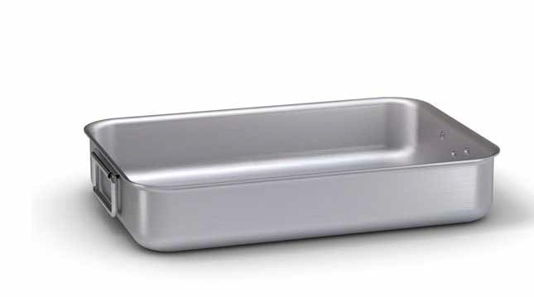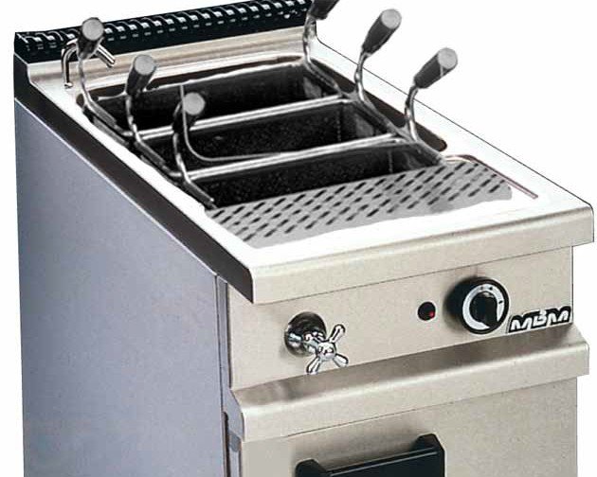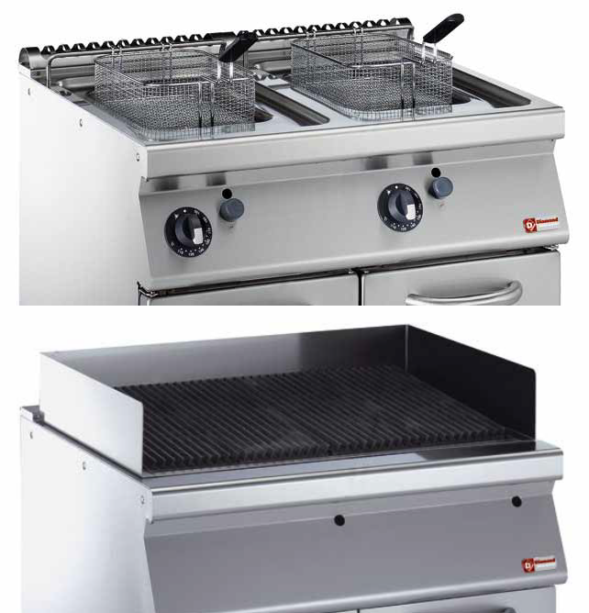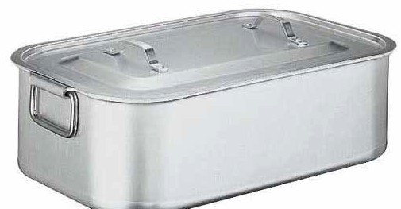

**Cooking**

**Technique**

**Equipment & utensils**

Braising

This is a method of slow cooking where the main ingredient is seared (scorched) or browned in fat and then simmered in liquid on a low heat in a covered pot.

Roasting

This is a technique used to cook large pieces of solid food in the oven or on a spit (a dry cooking method). During the cooking of meat, the fat in the meat melts and ‘bastes’ the meat, keeping it moist. If the meat is ‘lean’, then fat needs to be added into slits in the meat or the meat can be

‘marinated’ in liquid containing acid (vinegar, wine, lemon juice, etc.). ‘Basting’ is another method of keeping the meat moist. This involves bathing the outside of the meat with oil, pan drippings or a sauce during the cooking process.

Boiling

Food is cooked by immersing it in a liquid which can initially be hot or cold. The liquid may be, for example, water, salt and water, broth, milk, etc. At full boil the liquid will be so hot that bubbles of ‘vapour’ escape the liquid by moving fast enough to break the surface of the liquid and up into the air.

Frying

The food is cooked in fat up to a high temperature (+180°C) with the result that the ingredients being fried will be soft inside with a crisp, golden surface caused by the caramelization of sugars.

Grilling

The ingredients are placed on a grill and cooked by a dry direct heat at a high temperature that sears the ingredients in order for the juices to stay in.

**Ex 4. Games**

4A. Matching terms and functions 1

Using the images given in the glossary, choose some of them and match the image with the term and the function.

4B. Matching terms and functions 2

Using all the images given in the glossary, put them together in separate

groups:

▷ equipment for preparing food

▷ equipment for conserving food

▷ equipment for cooking

▷ equipment for washing up

▷ kitchen range

▷ others

4C. Memory game

Memory game 1: associate the image with the name of the tool.

Memory game 2: associate the image with the function of the tool.

**Ex 5. Do’s And Don’ts**

5A. Thought shower/pool

Think about and discuss what a good waiter/waitress should do. Add to a spidergram on the board as well as in your own notepads. Then do the same activity with what a good waiter/waitress should avoid.

5B. Rules 1

In pairs, write what a waiter/waitress must and must not do during service. At the end of the exercise, compare your table with the teacher’s table.

|  |  |  |
| --- | --- | --- |
| **Ser vice phase** | **Do’s** | **Don’ts** |
| Welcoming customers |  |  |
|  |  |  |
|  |  |  |
| Taking the order |  |  |
|  |  |  |
|  |  |  |
|  |  |  |
| Concluding the  Service |  |  |
|  |  |  |
|  |  |  |

5C. Rules 2

Re-order the do’s and don’ts from the sentences listed in exercise 5D.

|  |  |  |
| --- | --- | --- |
| **Ser vice phase** | **Do’s** | **Don’ts** |
| Welcoming customers |  |  |
|  |  |  |
|  |  |  |
| Taking the order |  |  |
|  |  |  |
|  |  |  |
|  |  |  |
| Concluding the  Service |  |  |
|  |  |  |

5D. Rules 3

Individually or in pairs put a tick after the sentences that show what a waiter/ waitress should do. Put a cross after sentences that show what a waiter/waitress should **not** do.

**PHASE 1: WELCOMING THE CUSTOMERS**

1. The waiter greets the customers and asks if they have a reservation.
2. The waiter leads the customers to a table in disarray, still to be cleared.
3. The waiter brings menus and asks if he can bring water or anything else to drink while the customers decide what they are having.
4. The waiter ignores the customers and doesn’t greet them.
5. The waiter leads the customers to their table and, where possible, asks where they would like to sit.
6. The waiter forgets to bring the menu and the customers have to summon him to ask for water.

**PHASE 2: SHOWING THE MENU AND TAKING THE ORDER**

1. The waiter interrupts while the customers are talking and only takes a partial order.
2. From a distance, and discreetly, the waiter checks that nothing is missing on the table; he must be alert to respond to any of the customer’s queries or needs. If possible, it is best to anticipate the customer.
3. The waiter returns to the table several times to ask for clarifications on certain courses. The waiter does not know how the dishes are cooked.
4. The waiter leaves the unnecessary settings on the table.
5. It is important to remove from the table any unnecessary place settings.
6. The waiter returns to the table and asks the customers if they are ready to order. The waiter gives details of the daily specials (if any) and takes the order.
7. The waiter is inattentive and does not see that the customers are calling him.
8. The order: it is important to know how each dish is prepared and to gather as much information as possible on how the customer wishes his dish to be cooked. It is important not to return to the table to ask for additional information on the courses ordered.

**PHASE 3: CONCLUDING THE SERVICE**

1. Once the bill is handed over, the waiter allows the customer to check it and decide how to pay (bank card, credit card, cash).
2. The waiter brings the bill in order to clear the table.
3. Once the bill is handed over, the waiter hovers by the client while waiting for the payment.
4. The waiter hands the customer the bill only after his request.

**Table for the teacher**

These are rules (do’s and don’ts) that a waiter/waitress should follow when serving customers. The exercises above relate to this table. (5B to 5D.)

|  |  |  |
| --- | --- | --- |
| **Ser vice phase** | **Do’s** | **Don’ts** |
| Welcoming customers | The waiter greets the customers and asks if they have a reservation. | The waiter ignores the customers and doesn’t greet them. |
|  | The waiter leads the customers to their table but, where possible, asks where they would like to sit. | The waiter leads the customers to a table in disarray, still to be cleared and cleaned. |
|  | The waiter brings menus and asks if the customers would like anything to drink while they decide what they are having. | The waiter forgets to bring the menu and the customers have to summon him. |
| Taking the order | The waiter returns to the table and asks the customers if they are ready to order. The waiter gives details of the daily specials (if any) and takes the order. | The waiter interrupts service to talk to someone else while the customers are ordering their food. The waiter only takes a partial order. |
|  | The order: it is important to know how each dish is prepared and to gather as much information as possible on how the customer wishes his dish to be cooked. It is important not to return to the table to ask for additional information on the courses ordered. | The waiter returns to the table several times to ask for clarifications on certain courses. The waiter does not know how  the dishes are cooked. The waiter does not ask how people like their meat to be cooked (rare, medium rare, well done). |
|  | It is important to remove from the table any unnecessary place settings. | The waiter leaves the unnecessary  settings on the table. |
|  | From a distance, and discreetly, the waiter checks that nothing is missing on the table; he must be alert to respond to any of the customers’ queries or needs.  If possible, it is best to anticipate the customers’ needs; for example, do they need the dessert menu? Would they like coffee? | The waiter is inattentive and does not see that the customers are calling him. |
| Concluding the  Service | The waiter hands the customer the bill only after it is requested. | The waiter tries to clear plates without checking if they are finished with. The waiter brings the bill in order to clear the table. |
|  | Once the bill is handed over, the waiter leaves, allowing the customer to check it and decide how to pay (bank card, credit card, cash). | Once the bill is handed over, the waiter hovers by the client while waiting for the payment. |

**Ex 6. Formal Speech**

6A. Formal and informal register

Add the sentences from Table 1 to Table 2, according to the service phases.

Choose the appropriate register (formal/informal).

**Table 1**

|  |  |
| --- | --- |
| **You (formal)** | **You (informal)** |
| Good evening! | Hello. |
| Do you have a reservation? | Did you book a table? |
| Where would you like to sit? | Where do you want to sit? |
| Please take your seats. | Sit down, please. |
| May I bring some water to drink? Still, sparkling?  Would you like anything else to drink? | Do you want something to drink? Still, sparkling?  Anything else to drink? |
| Here is the menu. | Here’s the menu. |
| Would you like the wine list? | Here’s the wine list. |
| Are you ready to order? | Can I take your order? |
| Our special dish of the day is... | Today’s special is... |
| Is the artichoke risotto for you? | Which one of you ordered the artichoke risotto? |
| Would you like to see the dessert menu? | Do you want any desserts? |
| May I bring you some coffee? | Can I bring you some coffee? |

|  |  |  |
| --- | --- | --- |
| **Service phases** | **Do’s** | **WHAT DOES THE WAITER SAY?** |
| Welcoming the customers | The waiter greets the customers and asks if they have a reservation. |  |
|  | The waiter leads the customers to their table and, where possible, asks where they would like to sit. |  |
|  | The waiter brings menus and asks if  he can bring water or anything else to  drink while the customers decide what  they are having. |  |
| Taking the order | The waiter returns to the table and asks the customers if they are ready to order. The waiter gives details of the daily specials (if any) and takes the order. |  |
|  | The order: it is important to know how each dish is prepared and to gather as much information as possible on how the customer wishes his dish to be cooked. It is important not to return to the table to ask for additional information on the courses ordered. |  |
|  | It is important to remove from the table any unnecessary place settings. |  |
|  | From a distance, and discreetly, the waiter checks that nothing is missing on the table; he must be alert to  respond to any of the customers’ queries or needs. If possible, it is best to anticipate the customer’s requirements. |  |
| Concluding the service | The waiter hands the customer the bill only after it is requested. |  |
|  | Once the bill is handed over, the waiter allows the customer to check it and decide how to pay (bank card, credit card, cash). |  |

**Ex 7. An Informal Dialogue**

7A. A listening exercise

Listen to the informal dialogue between a waiter and 2 customers in a pizza restaurant.

7B. Ordering text

Listen to the dialogue again and put the conversation in the right order.

Your teacher will give you the text.

7C. Informal dialogue: phrase gap fill

Listen to the dialogue again in parts and fill in the gaps in the text.

Your teacher will give you the text.

7D. Role play: an informal dialogue

In pairs or small groups, create an informal dialogue between a waiter/ waitress and one or two customers. You could use a different restaurant setting, for example: in a café or a burger bar. Then present your role play to the rest of the class.

**Ex 8. Formal Dialogue**

8A. Listening exercise

Listen to the formal dialogue between a waiter and two customers in a fine

dining restaurant (formal register).

8B. Ordering text

Listen to the dialogue again and put the conversation in the right order. Your teacher will give you the text.

8C. Formal dialogue: phrase gap fill

Listen to the dialogue again in parts and fill in the gaps in the text. Your teacher will give you the text.

8D. Role play: a formal dialogue

In pairs or small groups, create a formal dialogue between a waiter/waitress and one or two customers. A different fine dining restaurant setting could be used, for example, in a French or Indian restaurant. Then present your role play of the formal dialogue to the rest of the class.

8E. Discussing attitudes

Listen to the dialogues from exercise 7A and exercise 8A. Discuss the similarities and differences between:

▷ the attitudes of the two waiters

▷ how the customers and waiters relate to each other

▷ the situations/settings

**Ex 9. Challenging Situations – Creating Dialogues**

9A. Dealing with a challenging situation

Think of challenging situations that a waiter/waitress may come across in their job. Next, in groups of at least two people, choose a challenging situation and create a dialogue for it.

Then role play your challenging situation in front of the whole class. Discuss as a class how the situations were dealt with. Focus on what the waiter/waitress should say to the customer/s.

▷ The customer arrives and the restaurant is full.

▷ The wrong dish is served to the customer, who complains.

▷ The customer complains that their food is a little cold.

**Teacher’s tip:** *if the learners have access to computers, they can google web sites about dealing with difficult situations. For example:* [*http://www.4hoteliers.com/4hots_fshw.php?mwi=3830*](http://www.4hoteliers.com/4hots_fshw.php?mwi=3830)

**Ex 10. Taboo**

10A. Picture game

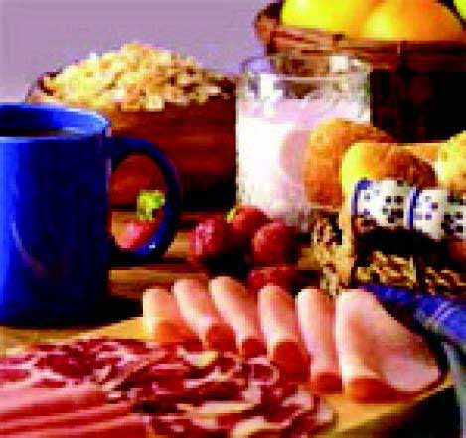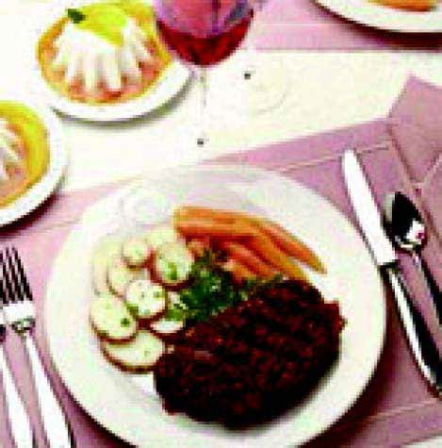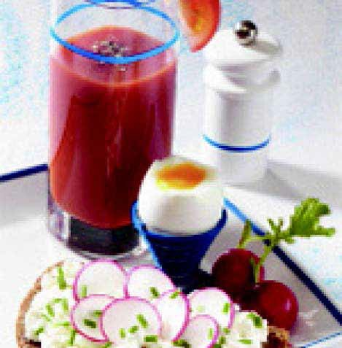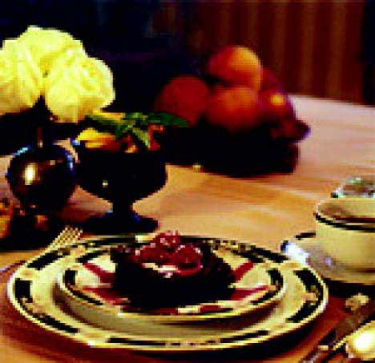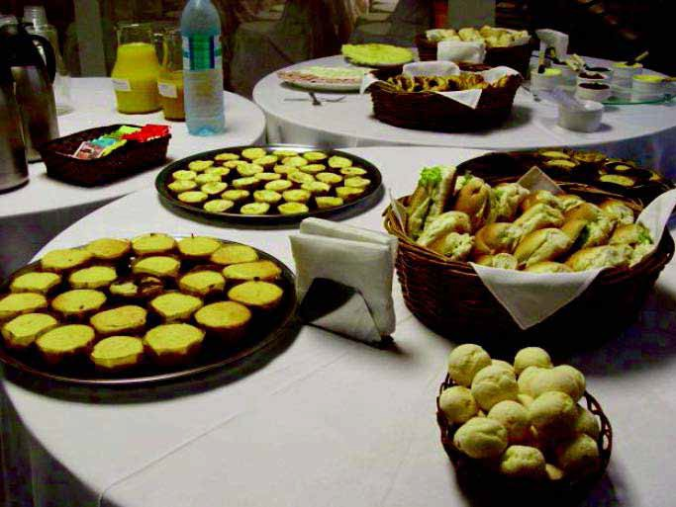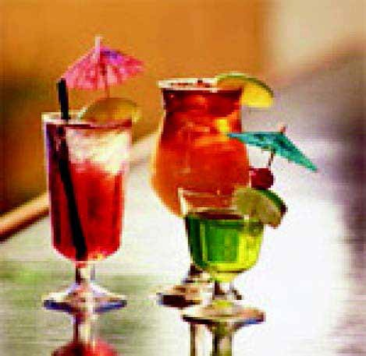

Choose one image and describe the type of service to your partner, without using the words below each picture.

**Dinner**

evening, family, home, pizzeria, restaurant, work

**Aperitif**

dinner, cocktail, wine, friends, evening, bar

**Coffee break**

work, colleagues, lecture, short, pause, coffee

**Lunch**

noon, break, pasta, abundant, meal

**Brunch**

breakfast, lunch, eggs, orange juice

**Breakfast**

morning, coffee, cappuccino, croissant, milk

**Ex 11. A Perfect Cappuccino**

11A. How to make a perfect cappuccino

Watch the video which shows how to make the perfect cappuccino:

<http://www.videojug.com/film/how-to-make-a-cappuccino-2>

Discuss the video, focusing on the parts of the coffee machine and the instructions. Cappuccino has many definitions depending on where you are in the world. In Italy, it’s a beverage generally consumed first thing in the morning, and is made of espresso and steamed milk.

11B. Writing the six steps to making a cappuccino

Watch the video again in parts and write down the six steps to making a cappuccino. Focus on the video’s specific terminology and use the list of words given below to help you. (These words are not necessarily in order.)

|  |  |  |  |  |
| --- | --- | --- | --- | --- |
| **to heat** | **shot** | **froth/frothy** | **filter** | **add** |
| **to turn on/off** | **tap (n.)** | **ready ground** | **pump pipes** | **power** |
| **dosing spoon** | **spoonful/s** | **grind** | **tank** | **button** |
| **single/double shot** | | **espresso** | **temperature** | **coffee machine** |
| **water** | **work surface** | **coffee beans** | **tamper** | **compact** |
| **drinking chocolate** | | **shake** | **sprinkle** | **swirl** |
| **turn** | **foam** | **tap (v.)** | **wipe** | **bubble** |
| **a wide-bottomed jug** | | **espresso maker** | **insert** | **grip handle** |
| **steam arm** | **steam** | **dosage** | **mix** | **full fat milk** |

* ______________________________________________
* ______________________________________________
* ______________________________________________
* ______________________________________________
* ______________________________________________
* ______________________________________________

11C. Ordering sentences

Watch the video again and put the sentences listed below in the right order (from 1 to 10) by writing the correct number by each sentence.

|  |  |
| --- | --- |
|  | The light of the machine will go out when the water is at the correct temperature. |
|  | Put the coffee in the filter basket and tap it to create a level surface. |
|  | Pour the milk on top of the espresso. |
|  | Use 7 grams of coffee for a single shot espresso and 14 grams for a double shot espresso. |
|  | Put a coffee cup underneath the machine, turn on the dosage button and wait for the coffee to filter through. |
|  | Steam the milk, preferably full fat milk, to create plenty of froth. |
|  | Turn on the boiler to heat the water to the correct temperature. |
|  | Add the correct amount of water into the tank of the machine. |
|  | Turn the steam arm on your coffee machine on full for five seconds before inserting it into the milk, as this will clean it through. |
|  | Tap the jug with the milk on a work surface to remove bubbles. |

11D. Explaining the six steps

Watch the video again and in pairs explain (orally) the six steps to making a cappuccino, with the help of the sentences and words from the above exercises.

**Teacher’s tip for 11A:** *the website also includes videos on how to make other types of coffee, which could be used as extension exercises or for a project on presenting how to make different coffees – if learners have access to the internet.*

**Teacher’s tip for 11D:** *you could also play the video mute while one or two more confident learners stand by the board and talk through the process of making a cappuccino.*

**Ex 12. Drink Categories**

12A. Types of drinks

Group the drinks (listed in the Menu in Table 1) into the beverage categories in Table 2.

**TABLE 1 (MENU)**

|  |  |  |  |
| --- | --- | --- | --- |
| Price list | | | |
| HOT BEVERAGES | | SOFT DRINKS | |
| Espresso | 1.65 | 330ml Highland Spring Water | 1.85 |
| Ginseng espresso | 1.70 | Draught beer (½ pint) | 1.90 |
| Ginseng espresso large | 1.90 | Draught beer (pint) | 2.50 |
| Decaffeinated coffee | 1.65 | Bottled beer | 3.50 |
| Caffè mocha | 1.90 | J20 Apple & Raspberry | 2.40 |
| Caffè latte | 1.90 | Fruit juices 200 ml | 1.80 |
| Caffè Americano | 1.90 | Water bottle 1,5 l | 1.80 |
| Cappuccino | 1.90 | Tonic water | 1.80 |
| Macchiato coffee | 1.90 | Cold tea | 2.00 |
| Hot chocolate | 1.70 | Cans Coca-cola, Fanta, Sprite | 1.00 |
| Hot chocolate with cream | 1.90 |  |  |
| Tea and other infusions | 1.65 |  |  |
| WINES | |  |  |
| 175ml glass of house wine | 2.65 | SPIRITS | |
| Glass of port | 2.70 | Brandy | 2.80 |
| Sparkling wine glass | 2.90 | Cognacs | 2.80 |
| APERITIFS | | Whisky cream | 3.00 |
| Non-alcoholic aperitifs | 1.50 | Gin, rum, tequila | 3.00 |
| Alcoholic aperitif | 2.50 | Sherry | 2.00 |
| House aperitif | 1.90 | Sambuca | 2.00 |
| Cocktails | 5.65 | Vermouth | 2.50 |
| SHAKES | | Vodka | 3.00 |
| Assorted milk shakes | 1.30 | Whisky | 2.70 |
| Fruit shakes | 2.50 | Extra mature whisky | 3.30 |
| Table service charge 10% | | | |

**TABLE 2 (BEVERAGE CATEGORIES)**

|  |  |
| --- | --- |
| **Nerve drinks**  Drinks containing substances that act upon the  nervous system generating excitement. |  |
| **Fruit juices**  Fruit juice is the by-product of fruit transfor-  mation, which at the end of the productive  processes, retains the original fruit’s taste and  flavour. |  |
| **Non-alcoholic beverages**  Non-alcoholic beverages can be sparkling or not; are packaged in a sealed bottle or other container,and prepared with natural drinking water –mineral or otherwise. |  |
| **Aperitifs**  Aperitifs are specific beverages that prepare the organism for a meal. |  |
| **Spirits**  Spirits are prepared by distilling (separating) a  substance from another, bringing a liquid to the vapour state and condensing it again. |  |
| **Machine-made drinks** |  |
| **Liqueurs**  A liqueur is a spirit based on sugar, alcohol and specific, distinguishing flavours (e.g. from trees, berries, flowers, or fruits). |  |
| **Beer**  An alcohol drink obtained from the fermentation of barley and other cereals, flavoured with hops. |  |

**TABLE 1 (FOR THE TEACHER)**

|  |  |
| --- | --- |
| **Nerve drinks**  Drinks containing substances that act upon the  nervous system generating excitement. | Coffee  Tea  Chocolate |
| **Fruit juices**  Fruit juice is the by-product of fruit transfor-  mation, which at the end of the productive  processes, retains the original fruit’s taste and  flavour. |  |
| **Non-alcoholic beverages**  Non-alcoholic beverages can be sparkling or not; are packaged in a sealed bottle or other container, and prepared with natural drinking water –mineral or otherwise. | Coca-cola  Fanta  Ginger ale  Tonic water  Sprite or Seven up  Lemon soda  Soda water |
| **Aperitifs**  Aperitifs are specific beverages that prepare the organism for a meal. | Dry white wine  Sparkling dry wines  Vermouths  Sherries  Bitters  Cocktails  Aniseed aperitifs  Wine-based aperitifs |
| **Spirits**  Spirits are prepared by distilling (separating) a  substance from another, bringing a liquid to the vapour state and condensing it again. | Gin  Rum  Vodka  Whisky  Brandy  Tequila |
| **Machine-made drinks** | Shakes  Milk-shakes  Fruit and vegetable crushes  Slushies |
| **Liqueurs**  A liqueur is a spirit based on sugar, alcohol and specific, distinguishing flavours (e.g. from trees, berries, flowers, or fruits). |  |
| **Beer**  An alcohol drink obtained from the fermentation of barley and other cereals, flavoured with hops. |  |

**Ex 13. Cocktails: Ingredients And How To Make A Cocktail**

13A. How to make a Mojita

Watch and discuss the video on how to make a simple Mojita; focusing on the ingredients (soda, mint leaves, sprig of mint, simple syrup, white rum, lemon twist), verbs (e.g. bruise, muddle, shake, jigger, measure out, garnish), measurement terms (e.g. ounce/s (oz) of, pinch of, tablespoon/s of, whole) and utensils (e.g. a cocktail spoon, a pour spout, a jigger (measuring cup), a muddler, a column sized glass and a metal shaker):

[http://www.youtube.com/watch?v=6qllpZ7fKuk&feature=related](http://www.youtube.com/watch?v=6qllpZ7fKuk&amp;feature=related)

13B. Create a cocktail

Read the cocktail list – focusing on the specific vocabulary. (You can look at images from the picture glossary or on the internet). Then divide into groups to create a new cocktail. Present the new cocktail to the rest of the class. The same activities could be used for non-alcoholic cocktails. Vote for your favourite cocktail!

Note: Measuring term 1/3 is stated as ‘one part’ and 6/10 is stated as ‘six parts’.

Cocktail list:

**Alexander**

▷ 1/3 Cream

▷ 1/3 Brown cocoa cream

▷ 1/3 Brandy

Shake with ice and serve in a cocktail glass. Grated nutmeg is optional.

**Americano**

▷ 1/2 Bitter

▷ 1/2 Red vermouth

Mix directly over ice in an old-fashioned glass. Add soda water. Garnish with half a slice of orange and lemon peel.

**Bacardi**

▷ 6/10 White rum

▷ 3/10 Lemon or lime juice

▷ 1/10 Grenadine syrup

Shake with ice and serve in a cocktail glass.

**Bloody Mary**

▷ 3/10 Vodka

▷ 6/10 Tomato juice

▷ 1/10 Lemon juice

Add a few drops of Worcestershire Sauce, Tabasco, celery salt, salt and pepper. Prepare in a tumbler with ice.

**Dry Manhattan**

▷ 7/10 Rye or Canadian whisky

▷ 3/10 Dry vermouth

▷ 1 drop of Angostura

Prepare in a mixing glass with ice. Serve in a cocktail glass. Garnish the glass with a lemon twist.

**Dry Martini**

▷ 8/10 Gin

▷ 2/10 Dry Vermouth

Prepare in a mixing glass with ice. Serve in a cocktail glass. May be served with a green olive and a lemon twist on top.

**Manhattan**

▷ 7/10 Rye or Canadian Whisky

▷ 3/10 Red Vermouth

▷ 1 drop of Angostura

Prepare in a frozen mixing glass and serve in a cocktail glass. Decorate with a red cherry.

**Margarita**

▷ 5/10 Tequila

▷ 3/10 Triple sec

▷ 2/10 Lime or lemon juice

Prepare in a shaker with ice. Serve in a cocktail glass with salt-encrusted rim.

**Negroni**

▷ 1/3 Gin

▷ 1/3 Red vermouth

▷ 1/3 Bitter Campari

Prepare in an old fashioned glass with ice. Add half an orange slice.

**Pina Colada**

▷ 3/10 White rum

▷ 2/10 Coconut milk

▷ 5/10 Pineapple juice

Shake in a blender with ice; serve in a tall drinking glass. Decorate with pineapple and a cherry.

**Vodka Martini**

▷ 8/10 Vodka

▷ 2/10 Dry vermouth

Prepare in a shaker. Serve in a cocktail glass. May be served with a green olive and a lemon twist on top.

13C. A good bartender

Think about the qualities and abilitites a good bartender should have – to be added to a spidergram on the board as well as in your own notepads. Then do the same activity about what a bartender’s tasks are.

**Teacher’s tip 13C:** *alternatively, you could divide the learners into two groups. Each group works on one spidergram before they present their findings to the whole class and add any other words as a whole group.*